AUTOMATION
What
The Automation component uses ServiceNow Flow Designer to automate the processing of Network Requests submitted through the Service Catalog.
The flow is triggered when a user submits the Network Request catalog item. It retrieves the submitted catalog variables, creates a corresponding record in the Network Database table, sends an email notification, requests approval, evaluates the approval result, and updates the Network Database record accordingly.
The automation reduces manual intervention and ensures that every request follows a standardized processing lifecycle.
Why
Without automation, network requests would require administrators or fulfilment teams to manually:
- Read submitted request information.
- Create corresponding database records.
- Notify relevant users.
- Request approvals.
- Check approval results.
- Update request status.
Automating these activities improves processing speed, consistency, traceability, and reliability.

Activity 1 – Creation of Flow
What
Create a Flow Designer flow named Network Request to control the automated lifecycle of the submitted catalog request.
How
- Navigate to Flow Designer.
- Open the Flow Designer home page.
- Click New.
- Select Flow.
- Enter: Flow Name: Network Request
- Provide an appropriate description, for example:
Automates the processing, approval, notification, and status update of Network Request catalog submissions.
- Click Build Flow.

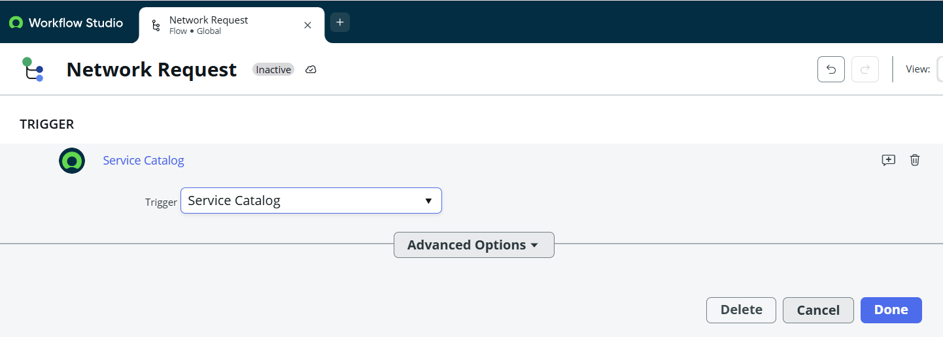

Activity 2 – Configure Trigger
What
Configure the flow to start automatically when the Network Request catalog item is submitted.
Why
A Service Catalog trigger ensures that automation begins immediately when a user submits a request instead of requiring an administrator to manually initiate the process.
How
- Open the Network Request flow.
- Click the (+) icon in the Trigger section.
- Select the appropriate Service Catalog trigger.
- Configure the trigger for the Network Request catalog submission.
- Click Done.
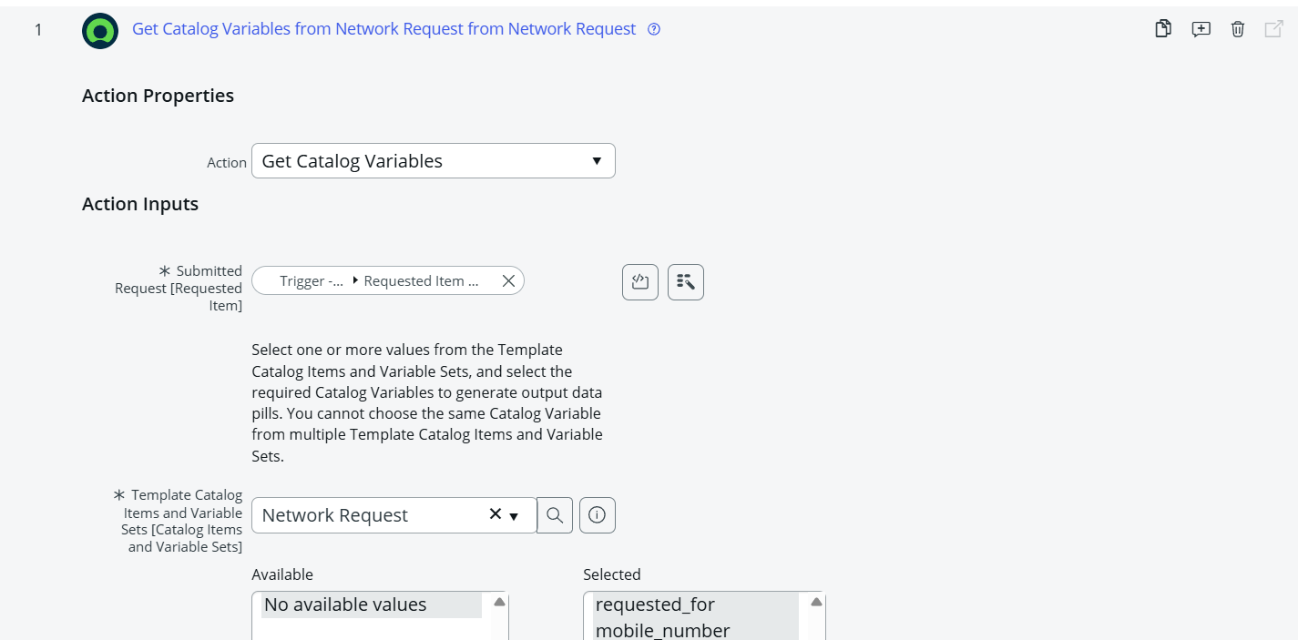
Activity 3 – Configure Flow Actions
The flow contains several actions that process the submitted request.
3.1 Get Catalog Variables
What
Retrieve the variables entered by the user in the Network Request catalog item.
Why
The submitted catalog variables contain the information required to create and process the corresponding Network Database record.
How
- Click Add an Action.
- Search for:
Get Catalog Variables
- Select Get Catalog Variables.
- Configure the action input using the catalog request's Requested Item from the trigger.
- Select the appropriate catalog item:
Network Request
- Select the required variables.
- Move the required variables into the selected area.
- Click Done.
Capture the action showing:
- Requested Item input
- Network Request catalog item
- Selected variables
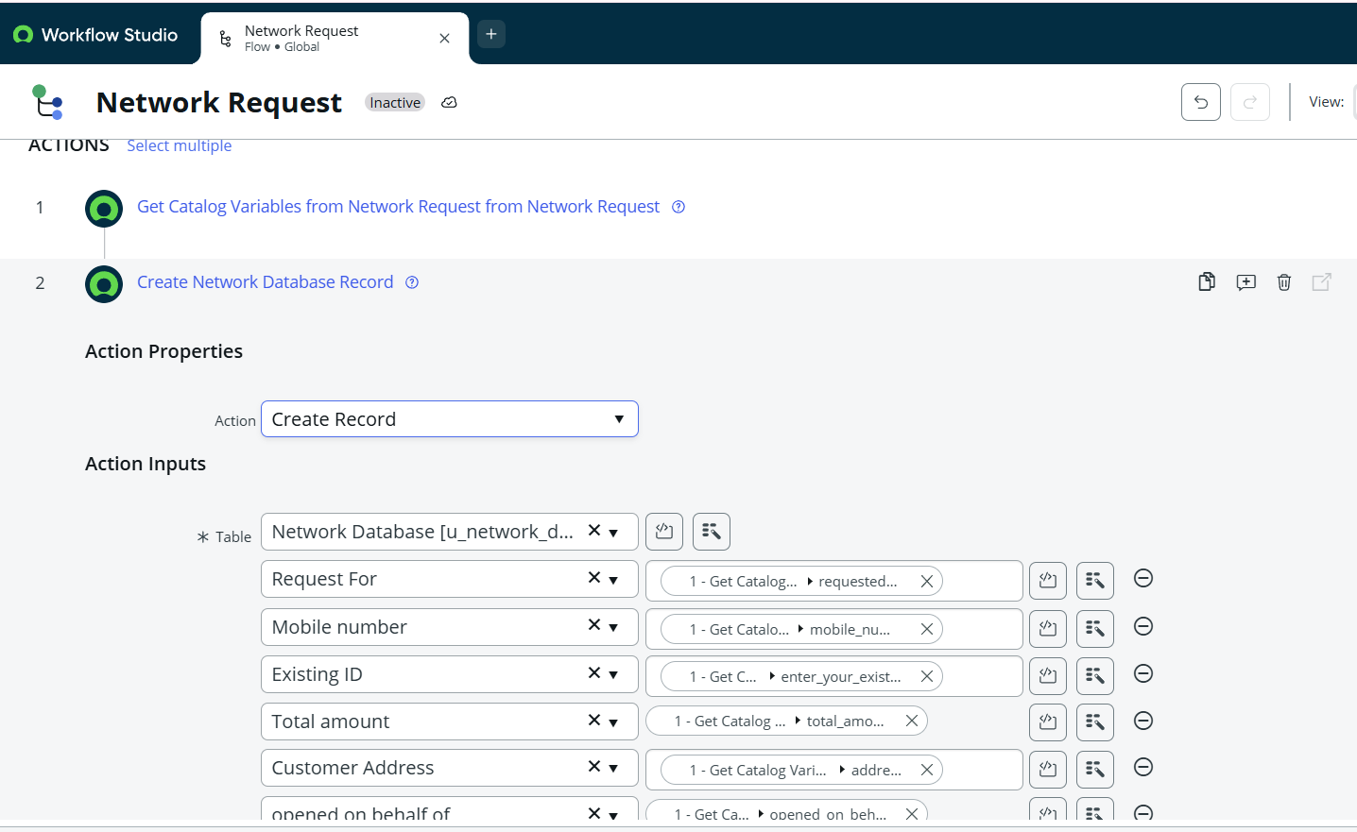
3.2 Create Record
What
Create a new record in the Network Database table using the information retrieved from the catalog variables.
Why
The catalog submission represents the user's request, while the Network Database record provides a structured record that can be used for approval, fulfilment, tracking, and reporting.
How
- Add a new action.
- Select Create Record.
- Select the table:
Network Database
- Click Add Fields.
- Map the appropriate catalog-variable outputs to the corresponding Network Database fields.
- Configure all required fields.
- Click Done.
3.3 Send Email
What
Send an email notification after the Network Database record is created.
Why
Notifications keep requesters and relevant stakeholders informed without requiring them to manually check the system.
How
- Add a Send Email action.
- Set the target record to the record created by the Create Record action.
- Configure the recipient fields:
  - To
  - CC, if required
  - BCC, if required
- Use static or dynamic recipients as appropriate.
- Configure the email Subject.
- Configure the email Body.
- Click Done.
Where possible, use dynamic values from the flow rather than hard-coded information.
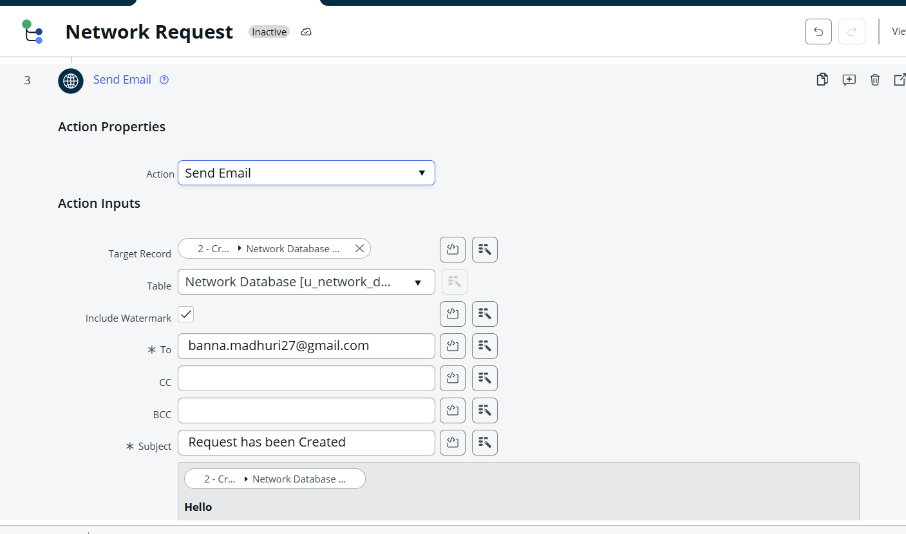Outcome
An automated notification is generated for the appropriate recipient after the Network Database record is created.
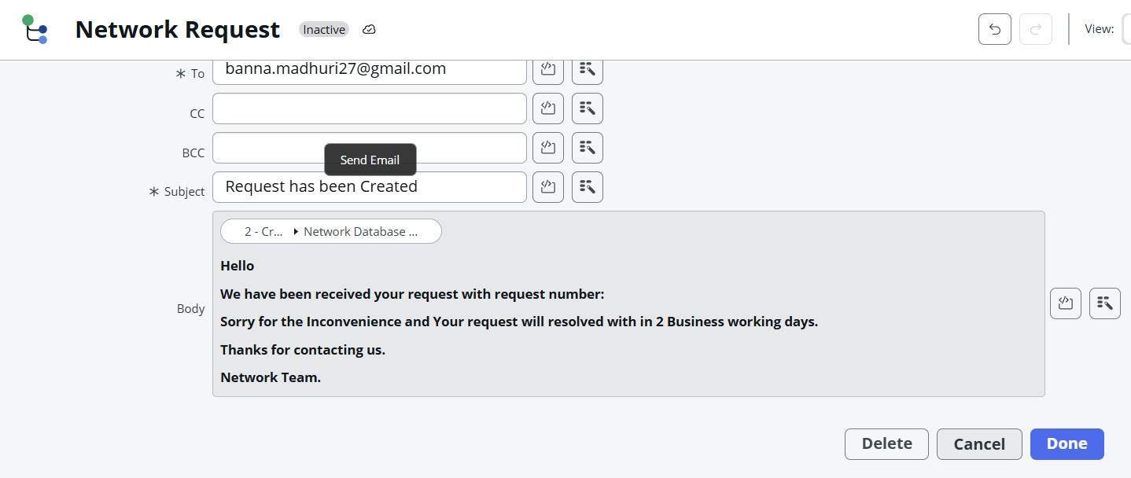
3.4 Ask for Approval
What
Configure an approval action to obtain authorization for the Network Request.
Why
Network-related requests may require authorization before fulfilment. Automating approval ensures that requests follow the organization's defined control process.
How
- Add the Ask for Approval action.
- Select the target record created by the Create Record action.
- Enter the approval reason:
Waiting for approval
- Configure the required approval rules.
- Select the appropriate approval behavior, such as:
  - Anyone approves
  - Everyone approves
- Configure static or dynamic approvers according to the requirement.
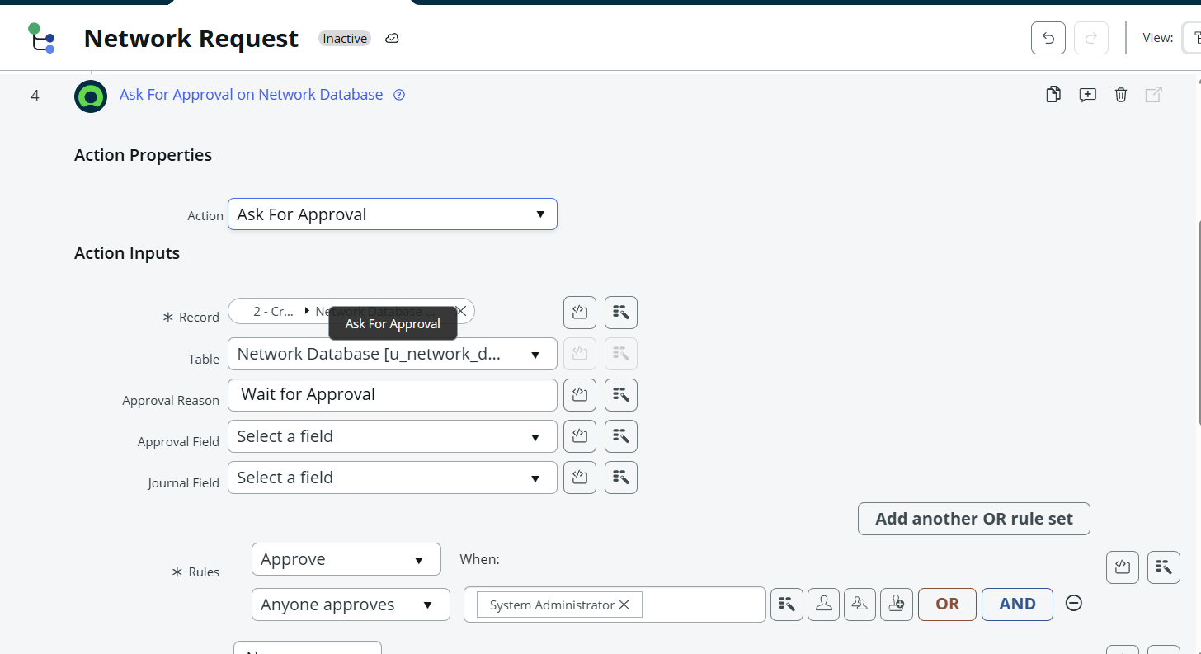
3.5 Flow Logic – Approval Decision
What
Add conditional logic to determine what happens based on the approval result.
Why
Approved and rejected requests require different processing paths. Conditional flow logic ensures that the correct action is taken automatically.
How
- Add Flow Logic.
- Select If.
- Configure the condition using the approval action's state.
- Set the condition to:
Approval State = Approved

3.6 Update Record – Approved Path
What
Update the Network Database record when the approval is successful.
Why
The request record must reflect the latest stage of the lifecycle so that fulfilment teams and users can understand its current status.
How
- Inside the Approved branch, add Update Record.
- Select the record generated by the Create Record action.
- Select the Network Database record.
- Configure the required fields.
- Set the appropriate approved status/value.
- Click Done.
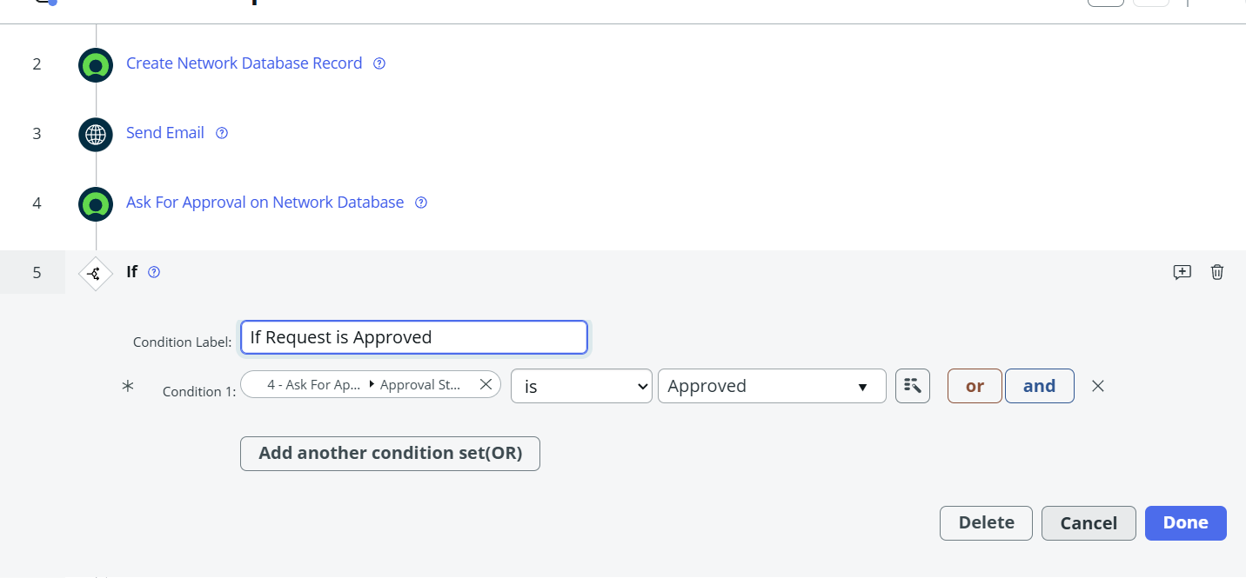
3.7 Else Path – Rejected Request
What
Configure the Else branch to handle requests that do not satisfy the approval condition.
Why
A rejected request must not continue through the normal approved processing path. Updating the record provides clear visibility into the rejection.
How
- Select the Else branch of the If condition.
- Add Update Record.
- Select the Network Database record created earlier.
- Configure the appropriate rejected status.
- Save the action.
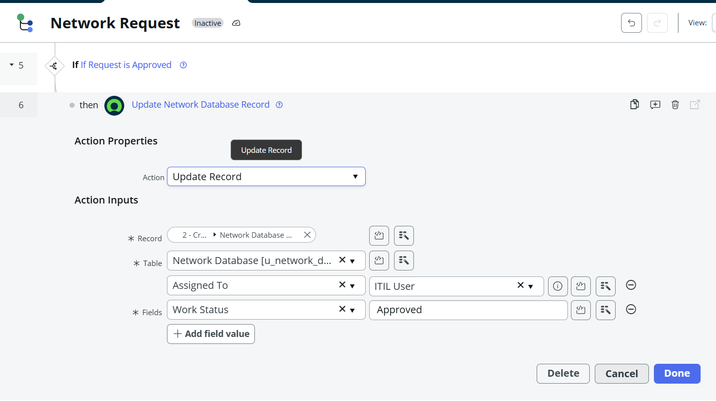

Outcome
Rejected requests are automatically identified and updated without continuing through the approved-request path.
The Automation phase establishes an end-to-end automated Network Request lifecycle in ServiceNow.
The completed automation performs the following sequence:
Catalog Submission → Retrieve Request Data → Create Network Database Record → Send Notification → Request Approval → Evaluate Decision → Update Record
This minimizes manual processing, standardizes request handling, improves approval traceability, and ensures that the Network Database record remains synchronized with the request's current lifecycle status.
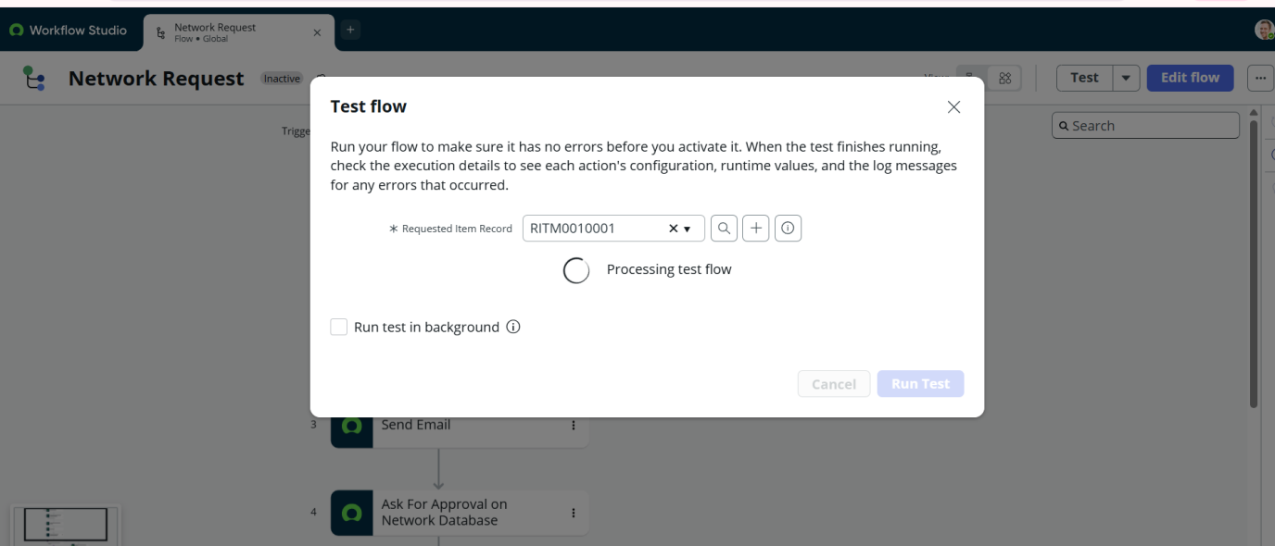
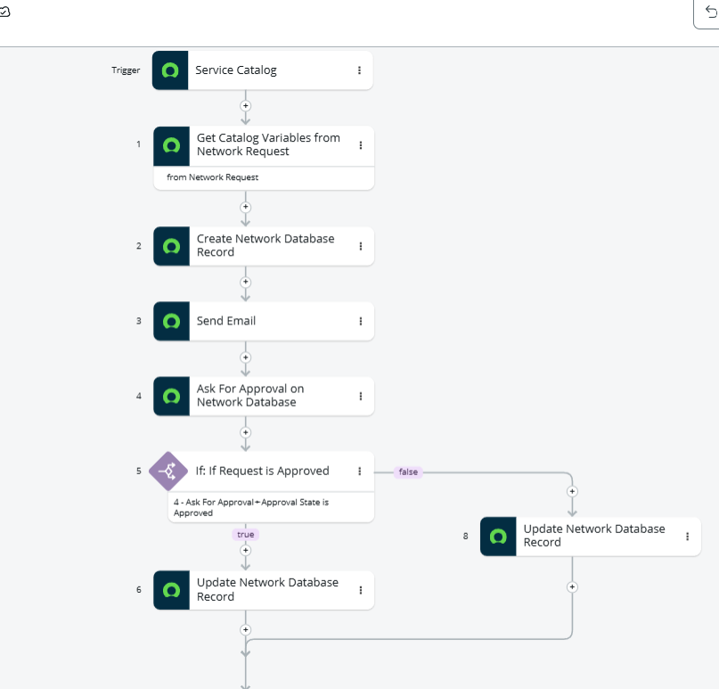

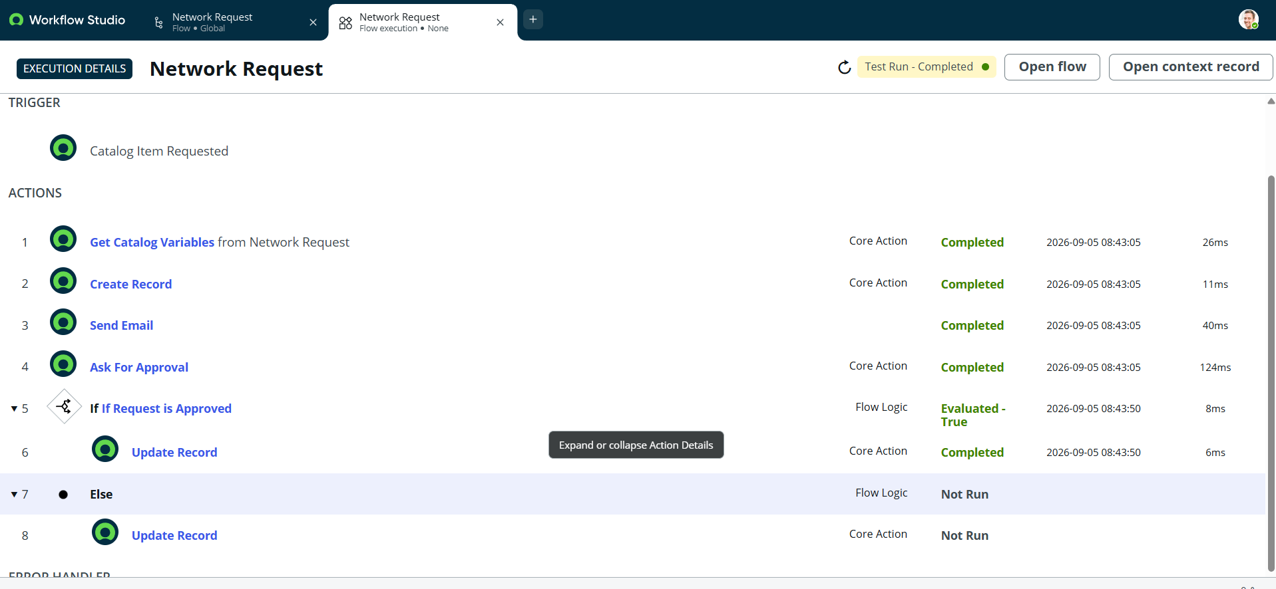
Replicability Note
The flow should be configured using dynamic data pills wherever possible. For example, the Network Database record created by Create Record should be reused as the target record for subsequent Send Email, Ask for Approval, and Update Record actions. This ensures that all actions operate on the same request record and makes the automation easier to maintain.

